NOTICE OF PUBLIC HEARING
CITY OF INKSTER, WAYNE COUNTY, MICHIGAN

RE: Case No. 19-05 (SLU)
In accordance with and pursuant to the Michigan Zoning Enabling Act, Act 110 of 2006, as amended, notice is hereby given that the City of Inkster Planning Commission will hold a public hearing on Monday, January 27, 2020, at 6:30 p.m., in the Inkster City Hall Council Chamber, located at 26215 Trowbridge, Inkster, Michigan, 48141. The purpose of this hearing is to consider special land uses to allow a Group Transitional Home in the B-2, Thoroughfare Mixed Use District. Ihsan Asmar, on behalf of Forever Care Homes is the applicant. The subject property is located on the east side of Inkster Rd, between Avondale Street and Woodsfield Street, and is legally described as follows:

TAX ID: 44 017 99 0001 002

19BB1A2 PT OF NW 1/4 SEC 19 T2S R10E DESC AS BEG N00DEG 04M 30S W 702FT FROM W 1/4 COR SEC 19 TH N00DEG 04M 30S W 98FT TH S89DEG 33M E 212FT TH S00DEG 04M 30S E 98FT TH N89DEG 33M W 212FT TO POB 0.48 AC
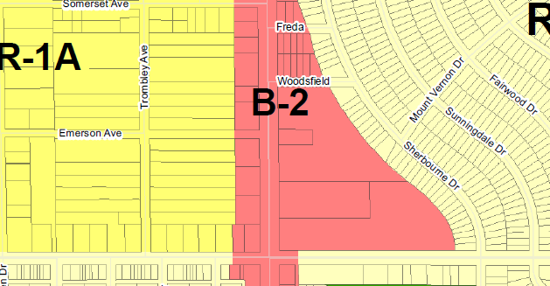

Inkster

Rd

NORTH

Public comments are invited. Persons unable to attend the public hearing may send their comments in writing to the attention of the City of Inkster Community Development Department, 26215 Trowbridge, Inkster, Michigan, 48141. Comments will be received through 12:00 noon, Monday, January 27, 2020. Please reference Case No. 19-05 (SLU) in all correspondence.

The City of Inkster will provide necessary reasonable auxiliary aids and services, such as signers for the hearing impaired and audio tapes of printed materials being considered at the public hearing to individuals with disabilities upon five business days written notice. Individuals with disabilities requiring auxiliary aids or services should contact the City of Inkster at 313.563.9770.

Felicia Rutledge
Inkster City Clerk
PUBLISH BY: January 10, 2020

Community Development Department • 313.563.9760

